#2.2:DATA COMPRESSION
Data compression reduces file size, allowing information to be stored and transmitted more efficiently while using less storage space and bandwidth. It is commonly applied to images, audio files, video streaming, and storage systems. The compression process works by eliminating redundant data or applying efficient encoding methods. As a result data can be represented using fewer bits than its original form. This leads to improved storage efficiency and faster data transfer within computer systems.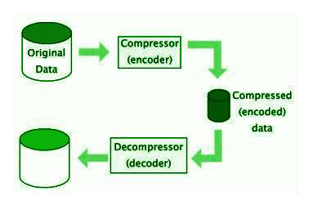

#2.2.1: Lossless Compression
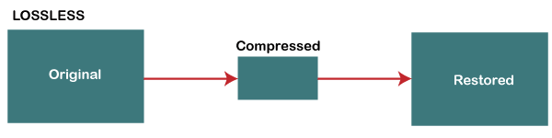
Lossless compression decreases file size while keeping all original data intact, making it possible to recreate the exact original file after decompression. This method works by detecting repeating patterns and data redundancy without discarding any information. It is especially important when accuracy and data integrity must be maintained. Common uses include text files, spreadsheets, and program files. A real-world example is zipping a Word document and later extracting it with no changes to its content. Another example is PNG images, which preserve full image quality even after compression and decompression..

